NCL and Tel Aviv University Establish the First Taiwan Resource Center for Chinese Studies in the Middle East
On January 8, 2020, National Central Library NCL Director-General Shu-hsien Tseng signed a cooperative agreement with Tel Aviv University Vice President Raanan Rein to establish a Taiwan Resource Center for Chinese Studies. An opening ceremony was also held, during which the placard for the new Center was unveiled. This is NCL’s first Taiwan Resource Center for Chinese Studies in the Middle East region.
Established in 1956, Tel Aviv University is Israel’s largest university. Its Central Library has in its collection books in a variety of languages and is actively engaged in digital services, providing substantial support for both teaching and research. Tel Aviv University is also an important East Asian research center in Israel and engaged in-depth exploration of civilizations in China, India, and Japan and their mutual interaction.
National Central Library selects important universities or research institutes overseas to set up centers, thereby augmenting collaboration with Chinese studies research institutions around the world, promoting the exchange of Chinese studies at home and abroad, and disseminating research achievements in Chinese studies from Taiwan. This project not only can increase interaction between NCL and research institutions abroad and provide many more opportunities for collaboration, but also can allow more people to come into contact with and use e-resources on Taiwan and Chinese studies, thus increasing Taiwan’s visibility and influence on the world stage.
In setting up this Taiwan Resource Center for Chinese Studies at Tel Aviv University, NCL provided 153 titles (214 volumes) on Chinese studies and Taiwan studies. In the future, new books will be sent each year. NCL also provided access to its numerous digital collections and e-book databases so that students and faculty at Tel Aviv University can access them. According to the stipulations in the collaborative agreement, Taiwan Lectures on Chinese Studies will be held at the Center in the future, as well as conferences and related exhibitions.
In working with Tel Aviv University to establish the Center, Vice President Rein thanked NCL in his remarks for providing such a rich assortment of physical and digital resources and enriching the holdings in their library. Representative Paul Kuoboug Chang from the Taipei Economic and Cultural Office in Tel Aviv was invited to make remarks as well. He expressed his wishes on the success of the Center. Tel Aviv University’s Central Library Director Naama Scheftelowitz also expressed her sincere thanks in the increase in quality of the library’s collections as a result of setting up this Center. Chair of the East Asian Department Dr. Ori Sela was very grateful for the replicas donated and the research resources provided by NCL, and hopes that this is the first step in a long collaborative journey.
The establishment of a Taiwan Resource Center for Chinese Studies is not only helpful in expanding scholarly exchange and spreading Taiwan-styled Chinese studies but also functions as a critical window internationally, making visible great books published in Taiwan and the abundance of e-resources for Chinese studies to many more people. On display are the achievements in Taiwan’s efforts to promote Chinese studies.

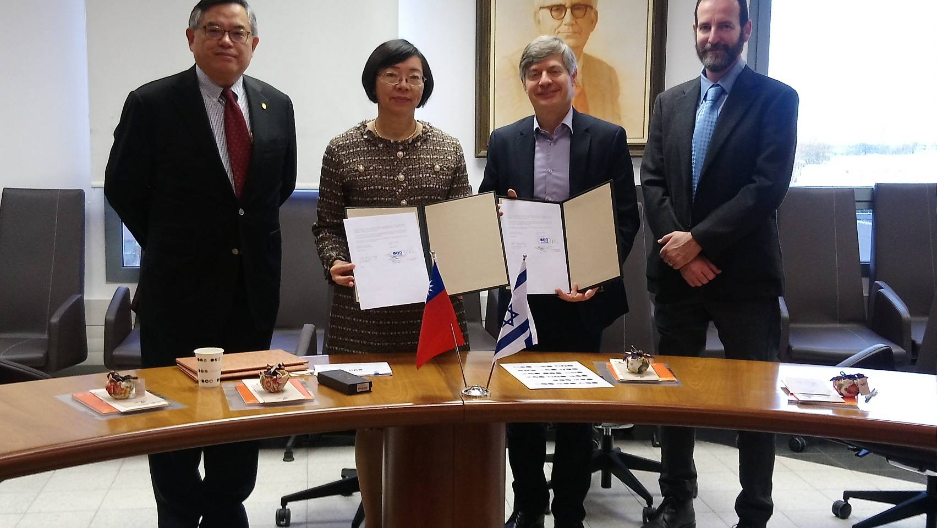

The Signing Ceremony

